# ***Magnets: The Magic Behind Levitation***

Magnets, those everyday objects that attract or repel certain metals, have a more magical side. They can defy gravity, making objects hover in mid-air. This phenomenon, known as magnetic levitation or maglev, has applications in various fields, from transportation to medical science.

How Maglev Works

To understand maglev, we need to grasp the concept of magnetic fields. A magnet creates an invisible field of force around it. When two magnets are brought close together, their magnetic fields interact. If the poles are the same (both north or both south), they repel each other. If the poles are different (one north, one south), they attract.

*Figure 1, A levitating disc shaped object using magnetic fields.*

Maglev systems use this principle to levitate objects. There are two main types:

1. 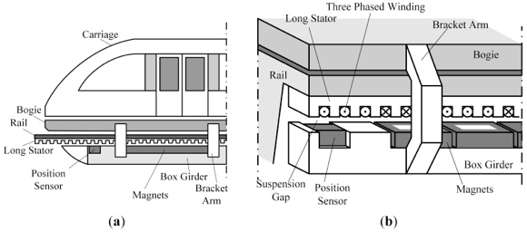**Electromagnetic Suspension (EMS):** In this system, electromagnets are used to both lift and propel the object. The electromagnets are constantly adjusted to maintain a specific distance between the magnet and the track, ensuring stable levitation.
2. **Electrodynamic Suspension (EDS):** This method relies on the principle of repulsion. A superconducting magnet on the vehicle interacts with coils in the track, generating a repulsive force that lifts the vehicle.

Applications of Maglev

*Figure 2, A diagram of a Maglev train and it’s parts.*

Maglev technology has numerous practical applications:

* **Maglev Trains:** These trains use powerful magnets to levitate above the track, reducing friction and enabling incredibly high speeds. They are energy-efficient and offer a smooth, quiet ride.
* **Magnetic Bearings:** These bearings use magnetic forces to support rotating shafts without physical contact. This reduces friction and wear, leading to increased efficiency and longevity.
* **Magnetic Separation:** Magnets can be used to separate magnetic materials from non-magnetic ones. This technique is used in various industries, such as mining and recycling.

The Future of Maglev

As technology continues to advance, we can expect to see even more innovative applications of maglev. Researchers are working on developing more efficient and powerful magnets, as well as exploring new ways to harness the power of magnetic levitation. From high-speed transportation to cutting-edge medical treatments, maglev has the potential to revolutionize our world.

In conclusion, Magnets, often taken for granted, hold the key to unlocking the secrets of levitation. By understanding the principles of magnetic fields and their interactions, we can harness this technology to create a future filled with wonder and innovation.

*Figure 3, experimenting with magnetic levitation pathways.*